CHAPTER THREE

SYSTEM ANALYSIS AND DESIGN

3.1 Introduction
In this chapter, we will discuss the system analysis as well as the design method of the ID card generation System and show the various techniques used to obtain information in order to have a better system design. We carried out requirement analysis in this chapter to review the entire system by providing diagram in form of graphical notation also it involves the analysis of the full description of the proposed system, which should lead to full specification of user requirements. The analysis clarifies what the system does while the design shows and describe how the system works.

3.2 Disadvantages of the existing system
- Time-Consuming: Manual processes are slow and labor-intensive, requiring significant time to design, print, and distribute ID cards.
- Human Error: There is a high risk of mistakes in data entry, design, and printing, leading to inaccuracies and the need for rework.
- Inconsistent Quality: Manually produced ID cards may vary in quality, with issues in alignment, printing clarity, and lamination.
- Limited Scalability: As the number of ID cards needed increases, manual systems struggle to keep up with demand, causing delays.
- Higher Costs: The labor and materials required for manual processes can be expensive, particularly when errors necessitate reprinting.
- Data Security Risks: Physical handling of sensitive information increases the risk of data breaches and unauthorized access.
- Tracking and Management: Manual systems lack efficient tracking and management capabilities, making it difficult to maintain records and update information.

3.3 Advantages of the proposed system
- Efficiency and Speed: Automated systems can rapidly process large volumes of data, generating ID cards quickly and accurately.
- Consistency and Quality: Automation ensures consistent quality in design, printing, and materials, reducing errors and variations.
- Cost-Effective: Reduces labor costs and material waste by minimizing errors and rework.
- Scalability: Easily handles large-scale ID card generation, accommodating growing organizations and institutions without delays.
- Enhanced Data Security: Digital processes offer better data protection, with encryption and controlled access to sensitive information.
- Integration and Automation: Can integrate with other systems (e.g., databases, HR software) for seamless data updates and card management.
- Real-Time Updates and Management: Allows for easy updates and management of ID card information, with real-time tracking and reporting capabilities.
- User-Friendly Interfaces: Often includes software with intuitive interfaces, making it easier for non-technical staff to operate.

3.4 The Proposed method
The proposed automated ID card generation system is designed to address the inefficiencies and errors inherent in manual ID card production. By leveraging modern technology, this system aims to streamline the entire process from data input to card distribution, ensuring speed, accuracy, and consistency. Integration with existing databases, such as HR or student information systems, allows for seamless data retrieval. This reduces the need for manual data entry and minimizes the risk of human errors, which are common in manual systems. A key feature of the automated system is the use of pre-designed templates for ID card creation. These templates ensure uniformity in the design and appearance of all cards, reflecting the organization’s branding and security requirements. Dynamic fields within the templates automatically populate with individual data from the database, ensuring personalized and accurate ID cards for each user. High-resolution printers are utilized to produce professional-quality ID cards, with options for including additional security features.
The system’s scalability is one of its significant advantages, allowing it to handle large volumes of ID card production efficiently. Batch printing capabilities enable the simultaneous production of multiple cards, significantly reducing the time and labor required compared to manual methods. This is particularly beneficial for large organizations or institutions with growing numbers of employees or students, as the system can easily accommodate increasing demand without performance degradation. Security is another critical aspect of the automated ID card generation system. Data encryption and secure access controls protect sensitive personal information during transfer and storage. Role-based access limits system usage to authorized personnel, enhancing data security. Additionally, the system maintains audit trails, providing accountability and traceability for all actions taken within the system. This level of security is essential for safeguarding personal data and preventing unauthorized access or data breaches.
Overall, the automated ID card generation system offers a comprehensive solution to the limitations of manual ID card production. It enhances efficiency, reduces costs, and ensures consistent quality, making it an invaluable tool for modern organizations. By implementing this system, organizations can streamline their ID card processes, improve data security, and effectively manage the production and distribution of ID cards.

3.5 Methods of data collection
The proposed method of data collection for the research on the "Id Card Generation System” involves a combination of primary and secondary data sources. It is important to note that ethical considerations, such as informed consent and data confidentiality, will be adhered to during the data collection process. Necessary permissions will be sought, and participants' identities will be protected to ensure privacy and confidentiality. By employing these methods of data collection, the research will gather comprehensive information and insights to understand the current Human Resource Management system, identify its limitations, and propose an effective solution for the problems.

3.6 System design

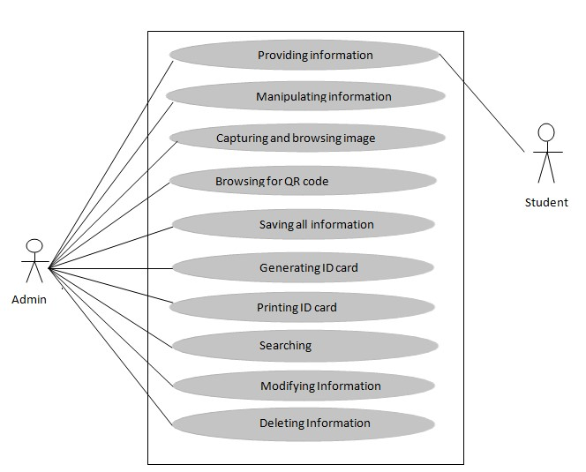
3.6.1 Algorithm diagrams
Figure 1Use Case diagram

3.6.2 System architecture
Figure 2 System Architecture
User Interface
Authentication and Autorization
Template Management
Data Validation
Id Card Generation
Printing
Distribution Tracking
Integration Layer
Database
Security Module
Audit and Report

3.6.3 Database tables
USER TABLE
Name | Datatype | Size | Relation
User_id | INT | 11 | Primary Key
User_role | VARCHAR | 11 | Not Null
Username | VARCHAR | 50 | NOT NULL
User_pass | VARCHAR | 50 | NOT NULL
Firstname | VARCHAR | 50 | NOT NULL
Lastname | VARCHAR | 50 | NOT NULL

ID CARD TABLE
NAME | DATATYPE | SIZE | RELATION
Id_card_id | INT | 11 | PRIMARY KEY
User_id | INT | 11 | FORIGN KEY
Template_id | INT | 11 | FORIGN KEY
Status | VARCHAR | 20 | NOT NULL
Generated_at | DATE |  | NOT NULL

PRINT TABLE
NAME | DATATYPE | SIZE | RELATION
Print_id | INT | 11 | PRIMARY KEY
Id_card_id | INT | 11 | FORIGN KEY
Printed_by | VARCHAR | 50 | NOT NULL
Printed_at | DATE |  | NOT NULL

3.6.4 Entity relationship modeling

Change

Password

ADMIN

Issue

ID_CARD

_year

_n
ame

Id_no

Valid_upto

Issue_date

Contact_no

program

image

Blood_group

Figure 3 Entity Relationship diagram

3.6.5 The input and output design
First Name
Last Name
Gender
Class
Term/Session
Date
Register
Cancel
Upload file image
Figure 4 Output Design
FULL NAME
GENDER
CLASS
DATE
STAFF SCHOOL FEDERAL POLYTECHNIC MUBI
Figure 5 Input Design

3.7 System requirement specification
The system requirement are the minimum hardware and software require for the development and implementation software being design below are the specification.

3.7.1 Hardware requirement
- Personal computer (P3 50MHZ Upward)
- 15’’ Visual Display Unit
- 4G RAM (Random Access Memory)
- 320GB Hard disk drive

3.7.2 Software requirement
- Window 7/10 pro above
- PHP 7
- MYSQL Database
- Xamp control panel
- Vs code text editor

